 | SHIFA TAMEER-E-MILLAT UNIVERSITY  Department of Computing

Software Requirement Specification
(SRS DOCUMENT)

for
Project Title
Version 1.0
By
M Wasim Adil BSCS-23F-0129
Zobia Shahid BSCS-23F-0143
Muhammad Qasim BSCS-23F-0126

Supervisor
Mr. Shujat Hussain

Co-Supervisor
Ma’am Jazba Firdous

Bachelor of Science in Computer Science (2023-2027)

Revision History
Name | Date | Reason for Changes | Version

Application Evaluation History
Comments (by committee)  *include the ones given at scope time both in doc and presentation | Action Taken

Supervised by
Supervisor’s Name
Signature______________

Table of Contents

1. Introduction 1
1.1 Purpose 1
1.2 Scope 1
1.3 Modules 1
2. Overall Description 1
2.1 Product Perspective 1
2.2 User classes and characteristics 1
2.3 Operating Environment 1
3. Requirement Identifying Technique 2
4. Functional Requirements 2
4.1 Functional Requirement X 2
4.1.1 System Functional Requirements, 3
4.1.2 Use Case Modeling, 3
4.1.3 Use Case Description, 3
4.1.4 Domain Model. 3
5. Non-Functional Requirements 3
5.1 Reliability 3
5.2 Usability 3
5.3 Performance 3
5.4 Security 4
5.5 Scalability 4
5.6 Robustness 4
5.7 Maintainability 4
6. External Interface Requirements 4
6.1 User Interfaces Requirements 4
6.2 Software interfaces 5
6.3 Hardware interfaces 5
6.4 Communications interfaces 5
7. References 5

Introduction

Purpose
This Software Requirements Specification (SRS) document defines the functional and non-functional requirements of Lostify AI, an AI-assisted recovery platform designed to support the reporting, searching, matching, verification, and recovery of missing persons, lost pets, and lost personal items.
The purpose of this document is to provide a clear and structured description of the system requirements for the development team, project supervisor, testers, and other stakeholders. It defines what the system shall provide, the users who will interact with it, the external interfaces required by the system, and the quality requirements that shall guide implementation and testing.
Lostify AI will provide a unified platform where users can submit structured cases containing information such as titles, descriptions, images, and last-known locations. The system will use artificial intelligence to assist in identifying potentially similar cases. AI-generated results will be presented as suggestions rather than final decisions, and sensitive or high-risk matches will require human verification.
The SRS will serve as a baseline for system design, implementation, testing, and evaluation. It will also establish traceability between the requirements defined for Lostify AI and the functionality implemented in the final project.

Scope
Lostify AI is a mobile and web-based recovery platform consisting of a citizen mobile application and a partner/administration web portal.
The system will support three primary recovery categories:
- Missing persons
- Lost pets
- Lost personal items
The citizen mobile application will allow users to:
- Register and authenticate their accounts.
- Create missing-person, lost-pet, and lost-item reports.
- Enter structured case information.
- Upload permitted images and evidence.
- Specify the last-known location using map-based services.
- View approved nearby cases.
- Submit sightings or tips.
- Receive relevant location-aware notifications.
- View AI-assisted matching suggestions.
- Track the status of submitted cases.
- Participate in controlled communication related to recovery cases.
- Confirm recovery after appropriate verification.
The AI-assisted matching service will process permitted images and generate visual representations called embeddings. These embeddings will be compared with existing case records to identify potentially similar cases. The system may also use object detection and OCR capabilities for supported cases. AI results will be ranked and presented as suggestions to assist users and authorized personnel rather than automatically confirming identity or ownership.
The partner and administration portal will allow authorized users to:
- Review submitted reports.
- Verify case information and evidence.
- Review AI-generated matching suggestions.
- Manage users and roles.
- Approve relevant broadcasts and notifications.
- Monitor cases and recovery outcomes.
- Review audit information.
- Access authorized analytics and case summaries.
The system will use location information to support nearby-case discovery and controlled alerts. Security mechanisms will be applied to protect accounts, case information, uploaded evidence, and sensitive data.
The initial project scope is limited to an academic prototype using test data. It will not directly integrate with live police, hospital, shelter, telecom, or other government databases without appropriate authorization. The system will also not provide automatic legal identification, emergency dispatch, or real-time tracking without explicit user consent.

Modules
Lostify AI is divided into the following major modules.

Citizen Mobile Application
The Citizen Mobile Application is the primary interface for citizens, families, pet owners, volunteers, and community members.
It provides functionality for:
- User registration and authentication.
- Case reporting.
- Image and evidence upload.
- Location selection.
- Nearby case browsing.
- Sighting submission.
- Case status tracking.
- Notifications.
- Controlled communication.
- QR scanning for supported registered pets or valuables.
- Recovery confirmation.

AI-Assisted Matching Services
The AI-Assisted Matching Services provide intelligent analysis to support the recovery process.
The module will include:
- Image preprocessing.
- Image embedding generation.
- Image similarity comparison.
- Ranked matching results.
- Top-5 candidate retrieval.
- Object detection for supported cases.
- OCR for permitted textual information.
- Duplicate-report detection.
- AI confidence/similarity information.
The initial implementation will use transfer learning with pretrained models rather than training computer-vision models entirely from scratch.
AI output will remain advisory and will require appropriate human review before a sensitive match or recovery is confirmed.

Partner and Administration Portal
The Partner and Administration Portal provides authorized organizations and administrators with tools for managing and reviewing recovery cases.
It will support:
- Case review.
- Verification queues.
- Evidence review.
- Role management.
- Authorized partner access.
- Broadcast management.
- Case monitoring.
- Recovery analytics.
- AI result review.
- Authorized case-summary generation.
- Audit-log review.

Security and Communication Module
The Security and Communication Module provides mechanisms for protecting system information and supporting communication between authorized users.
It will include:
- Role-based access control.
- Protected user sessions.
- Secure evidence storage.
- Controlled access to sensitive case information.
- Location-aware notifications.
- Owner verification questions.
- Recovery/handover confirmation.
- Audit logging.
- Controlled communication between relevant users.
The module is intended to ensure that Lostify AI supports recovery coordination while maintaining privacy, security, accountability, and human oversight.
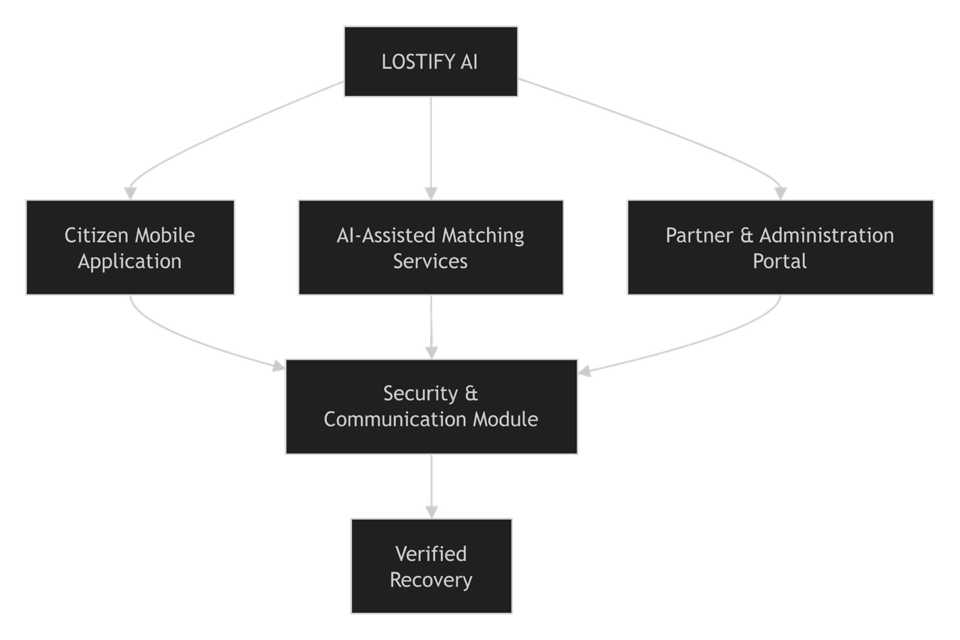
Figure 1: High-Level Module Structure of Lostify AI

Overall Description
This section presents a high-level overview of the product and the environment in which it will be used, the anticipated users, and known constraints, assumptions, and dependencies.

Product Perspective
Describe the product’s context and origin. Is it the next member of a growing product line, the next version of a mature system, a replacement for an existing application, or an entirely new product? Consider including visual models such as a context diagram to show the product’s relationship to other systems. See Appendix A for an example of context diagram.

User classes and characteristics
Identify the various user classes that you anticipate will use this product, and describe their pertinent characteristics. See Appendix A for an example of how to present user classes and charateristics.

Operating Environment
Describe the environment in which the software will operate, which might include the hardware platform; operating systems and versions; geographical locations of users, servers, and databases; and organizations that host the related databases, servers, and websites.
Example:

OE-1:The System shall operate correctly with the following web browsers: Windows Internet Explorer versions 7, 8, and 9; Firefox versions 12 through 26; Google Chrome (all versions); and Apple Safari versions 4.0 through 8.0.

Requirement Identifying Technique
This section describes the requirements identifying technique(s) which further help to derive functional requirements specification. The selection of the technique(s) will depend on the type of project. For instance,
- Interviews
- Questionare and Surveys
- Observations
- Workshops and Training's
- Story boarding for graphically intensive applications.

Examples of above techniques are given in Appendix A

Functional Requirements
This section describes the functional requirements of the system expressed in the natural language style. This section is typically organized by feature as a system feature name and specific functional requirements associated with this feature. It is just one possible way to arrange them. Other organizational options include arranging functional requirements by use case, process flow, mode of operation, user class, stimulus, and response depend on what kind of technique has been used to understand functional requirements. Hierarchical combinations of these elements are also possible, such as use cases within user classes. For further detail see Chapter 10 “Documenting the requirements”. Let consider the feature scheme as an example.

Functional Requirement X
Itemize the specific functional requirements associated with each feature. These are the software capabilities that must be implemented for the user to carry out the feature’s services or to perform a use case. Describe how the product should respond to anticipated error conditions and to invalid inputs and actions. Uniquely label each functional requirement, as described earlier. You can create multiple attributes for each functional requirement, such as rationale, source, dependencies, etc. The following template is required to write functional requirements. For further detail see Chapter 11” Writing excellent requirements”.

Table 1: Description of FR-1
Identifier | FR-1
Title | Title of requirement
Requirement | Description of requirement which may be written either from the user or system perspective e.g.  If written in a user perspective  The [user class or actor name] shall be able to [do something] [to some object] [qualifying conditions, response time, or quality statement].  If written in a system perspective  [optional precondition] [optional trigger event] the system shall [expected system response]
Source | Where this requirement comes from (who originate it)
Rationale | The motivation behind the requirement
Business Rule (if required) | Any restriction, policy, the rule that the particular requirement must be fulfilled through its functional behavior
Dependencies | Requirements ID that is dependent on this requirement
Priority | High/Medium/Low

System Functional Requirements,
System requirements is a statement that identifies the functionality that is needed by a system in order to satisfy the customer's requirements.These can be broadly classified as functional requirements, data requirements, quality requirements and constraints. They are often provided to consumers in complete detail. System requirements often indicate the minimum and the recommended configuration.

Use Case Modeling,
A Use Case Model describes the proposed functionality of a new system. A Use Case represents a discrete unit of interaction between a user (human or machine) and the system. See Appendix

Use Case Description
A use case is a written description of how users will perform tasks on your website. It outlines, from a user's point of view, a system's behavior as it responds to a request. See Appendix

Domain Model.
Domain model is a structured visual representation of interconnected concepts or real-world objects that incorporates vocabulary, key concepts, behavior, and relationships of all of its entities

Non-Functional Requirements
This section specifies nonfunctional requirements other than constraints, which are recorded in section 2.3, and external interface requirements, which will appear in section 7. These quality requirements should be specific, quantitative, and verifiable. Chapter 14 “beyond functionality” presents more information about these quality attribute requirements and many examples. The following are some examples of documenting guidelines.

Reliability
Requirements about how often the software fails. The measurement is often expressed in MTBF (mean time between failures). The definition of a failure must be clear. Also, don't confuse reliability with availability which is quite a different kind of requirement. Be sure to specify the consequences of software failure, how to protect from failure, a strategy for error detection, and a strategy for correction.

Usability
Usability requirements deal with ease of learning, ease of use, error avoidance and recovery, the efficiency of interactions, and accessibility. The usability requirements specified here will help the user interface designer create the optimum user experience.
Example:

USE-1: The COS shall allow a user to retrieve the previous meal ordered with a single interaction.

Performance
State specific performance requirements for various system operations. If different functional requirements or features have different performance requirements, it’s appropriate to specify those performance goals right with the corresponding functional requirements, rather than collecting them in this section.
Example:

PER-1: 95% of webpages generated by the COS shall download completely within 4 seconds from the time the user requests the page over a 20 Mbps or faster Internet connection.

Security
One or more requirements about protection of your system and its data. The measurement can be expressed in a variety of ways (effort, skill level, time, ...) to break into the system. Do not discuss solutions (e.g. passwords) in a requirements document.

Scalability
Scalability refers to the ability of an organization (or a system, such as a computer network) to perform well under an increased or expanding workload. A system that scales well will be able to maintain or increase its level of performance even as it is tested by larger and larger operational demands.

Robustness
the quality or condition of being strong and in good condition. the ability to withstand or overcome adverse conditions or rigorous testing

Maintainability
Maintainability is defined as the probability that a failed component or system will be restored or repaired to a specified condition within a specified period or time when maintenance is performed in accordance with prescribed procedures

External Interface Requirements
This section provides information to ensure that the system will communicate properly with users and with external hardware or software elements. A complex system with multiple subcomponents should create a separate interface specification or system architecture specification. The interface documentation could incorporate material from other documents by reference. For instance, it could point to a hardware device manual that lists the error codes that the device could send to the software.

User Interfaces Requirements
Describe the logical characteristics of each user interface that the system needs. Some possible items to include are
- References to GUI standards or product family style guides that are to be followed.
- Standards for fonts, icons, button labels, images, color schemes, field tabbing sequences, commonly used controls, and the like.
- Screen layout or resolution constraints.
- Standard buttons, functions, or navigation links that will appear on every screen, such as a help button.
- Shortcut keys.
- Message display conventions.
- Layout standards to facilitate software localization.
- Accommodations for visually impaired users.
Document the user interface design details, such as specific dialog box layouts, in a separate user interface specification, not in the SRS. Including screen mock-ups in the SRS to communicate another view of the requirements is helpful but make it clear that the mock-ups are not the committed screen designs. If the SRS is specifying an enhancement to an existing system, it sometimes makes sense to include screen displays exactly as they are to be implemented. The developers are already constrained by the current reality of the existing system, so it's possible to know up front just what the modified, and perhaps the new, screens should look like.

Software interfaces
Describe the connections between this product and other software components (identified by name and version), including other applications, databases, operating systems, tools, libraries, websites, and integrated commercial components (If any).
Example:

SI-1: Cafeteria Inventory System
SI-1.1: The COS shall transmit the quantities of food items ordered to the Cafeteria Inventory System through a programmatic interface.

Hardware interfaces
Describe the characteristics of each interface between the software components and hardware components, if any, of the system. This description might include the supported device types, the data and control interactions between the software and the hardware, and the communication protocols to be used.
    - Compatibility Requirements
This means that programs, devices and systems must interact with each other without issues arising. For a system to be compatible, all components must agree on how they will exchange data and commands.

    - Operating Requirements
Requirement that specifies an operation or behavior that a system, or part of a system, must perform.

Communications interfaces
State the requirements for any communication functions the product will use, including email, web browser, network protocols, and electronic forms.

Example:

CI-1: The COS shall send an email or text message (based on user account settings) to the Patron to confirm acceptance of an order, price, and delivery instructions.

References
List any documents or other resources to which this SRS refers, if any. These might include user interface style guides, standards, system requirements specifications, interface specifications, or the SRS for a related product. The following are a few examples of different resources i.e. journal article, book, and website.

  - Lyda M.S. Lau, Jayne Curson, Richard Drew, Peter Dew and Christine Leigh, (1999), Use Of VSP Resource Rooms to Support Group Work in a Learning Environment, ACM 99, pp-2. (Journal paper example)
  - Hideyuki Nakanishi, Chikara Yoshida, Toshikazu Nishmora and TuruIshada, (1996), FreeWalk: Supporting Casual Meetings in a Network, pp 308-314 (paper on web) http://www.acm.org/pubs/articles/proceedings/cscw/240080/p308-nakanishi.pdf
  - Ali Behforooz& Frederick J.Hudson, (1996), Software Engineering Fundamentals, Oxford University Press. Chapter 8, pp255-235. (book reference example)
  - Page Author, Page Title, http://www.bt.com/bttj/archive.htm, Last date accessed. (web site)

Appendix A

Example: Context Diagram

The Cafeteria Ordering System is a new software system that replaces the current manual and telephone processes for ordering and picking up meals in the Process Impact cafeteria. The context diagram in Figure 1 illustrates the external entities and system interfaces.
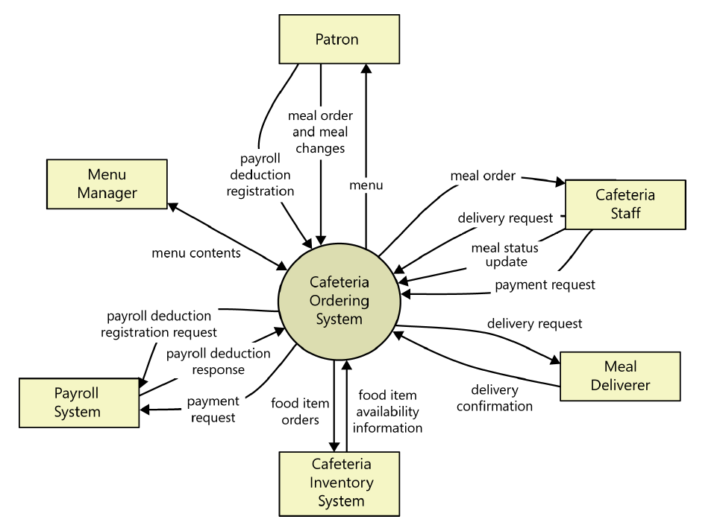

Figure 2: Context diagram of the Cafeteria Ordering System.

Example: User Classes and Characteristics

Table 1 Shows user classes and characteristic for Cafetaria ordering system
User class | Description
Patron | A Patron is a Process Impact employee who wants to order meals to be delivered from the company cafeteria. There are about 600 potential Patrons, of which 300 are expected to use the COS an average of 5 times per week each. Patrons will sometimes order multiple meals for group events or guests. An estimated 60 percent of orders will be placed using the corporate intranet, with 40 percent of orders being placed from home or by smartphone or tablet apps.
Cafeteria Staff | The Process Impact cafeteria employs about 20 Cafeteria Staff who will receive orders from the COS, prepare meals, package them for delivery, and request delivery. Most of the Cafeteria Staff will need training in the use of the hardware and software for the COS.
Menu Manager | The Menu Manager is a cafeteria employee who establishes and maintains daily menus of the food items available from the cafeteria. Some menu items may not be available for delivery. The Menu Manager will also define the cafeteria’s daily specials. The Menu Manager will need to edit existing menus periodically.
Meal Deliverer | As the Cafeteria Staff prepare orders for delivery, they will issue delivery requests to a Meal Deliverer’s smartphone. The Meal Deliverer will pick up the food and deliver it to the Patron. A Meal Deliverer's other interactions with the COS will be to confirm that a meal was (or was not) delivered.

Example: Use case Diagram

Following use case diagram is of an appointment system in which all the use case diagram relationships are presented. In further in Table 2 to the detail of use case diagram sytax is provided.

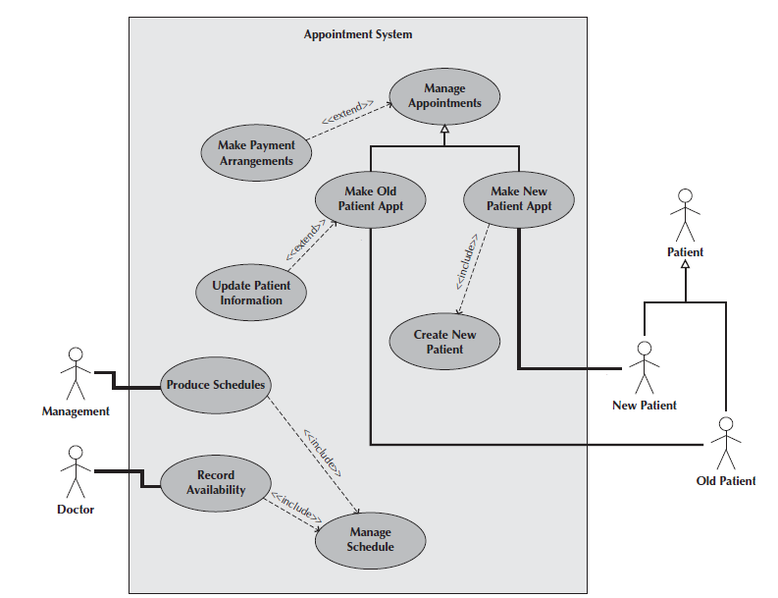

Figure 3: Use Case Diagram of an Appointment System

Syntax for Use case Diagram

Table 2 Syntax for Use case Diagram
An actor:  ■ Is a person or system that derives benefit from and is external to the subject.  ■ Is depicted as either a stick figure (default) or, if a nonhuman actor is involved, a  rectangle with <<actor>> in it (alternative).  ■ Is labeled with its role.  ■ Can be associated with other actors using a specialization/superclass association,  denoted by an arrow with a hollow arrowhead.  ■ Is placed outside the subject boundary. | 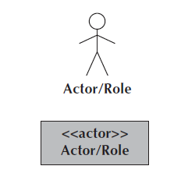
A use case:  ■ Represents a major piece of system functionality.  ■ Can extend another use case.  ■ Can include another use case.  ■ Is placed inside the system boundary.  ■ Is labeled with a descriptive verb–noun phrase. | 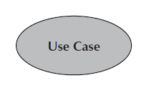
subject boundary:  ■ Includes the name of the subject inside or on top.  ■ Represents the scope of the subject, e.g., a system or an individual  business process. | 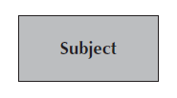
An association relationship:  ■ Links an actor with the use case(s) with which it interacts. | 
An include relationship:  ■ Represents the inclusion of the functionality of one use case within another.  ■ Has an arrow drawn from the base use case to the used use case. | 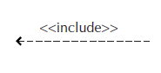
An extend relationship:  ■ Represents the extension of the use case to include optional behavior.  ■ Has an arrow drawn from the extension use case to the base use case. | 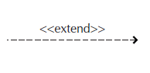
A generalization relationship:  ■ Represents a specialized use case to a more generalized one.  ■ Has an arrow drawn from the specialized use case to the base use case. | 

Detail Use Case Example
The Table 3 below indicate a comprehensive use case template filled in with an example drawn from the Cafeteria ordering system (COS).

Table 3 Show the detail use case template and example
Use Case ID: | Enter a unique numeric identifier for the Use Case. e.g. UC-1
Use Case Name: | Enter a short name for the Use Case using an active verb phrase. e.g.  Order a Meal
Actors: | [An actor is a person or other entity external to the software system being specified who interacts with the system and performs use cases to accomplish tasks.] e.g.
  Primary Actor: | Patron | Secondary Actors: | Cafeteria Inventory System
Description: | [Provide a brief description of the reason for and outcome of this use case.] e.g.  A Patron accesses the Cafeteria Ordering System from either the corporate intranet or external Internet, views the menu for a specific date, selects food items, and places an order for a meal to be picked up in the cafeteria or delivered to a specified location within a specified 15-minute time window.
Trigger: | [Identify the event that initiates the use case.]e.g.  A Patron indicates that he wants to order a meal.
Preconditions: | [List any activities that must take place, or any conditions that must be true, before the use case can be started.  PRE-1. Patron is logged into COS.  PRE-2. Patron is registered for meal payments by payroll deduction.
Postconditions: | [Describe the state of the system at the conclusion of the use case execution.  POST-1. Meal order is stored in COS with a status of “Accepted.”  POST-2. Inventory of available food items is updated to reflect items in this order.  POST-3. Remaining delivery capacity for the requested time window is updated.
Normal Flow: | [Provide a detailed description of the user actions and system responses that will take place during execution of the use case under normal, expected conditions.  1.0 Order a Single Meal  1. Patron asks to view menu for a specific date. (see 1.0. E1, 1.0.E2)  2. COS displays menu of available food items and the daily special.  3. Patron selects one or more food items from menu. (see 1.1)  4. Patron indicates that meal order is complete. (see 1.2)  5. COS displays ordered menu items, individual prices, and total price, including taxes and delivery charge.  6. Patron either confirms meal order (continue normal flow) or requests to modify meal order (return to step 2).  7. COS displays available delivery times for the delivery date.  8. Patron selects a delivery time and specifies the delivery location.  9. Patron specifies payment method.  10. COS confirms acceptance of the order.  11. COS sends Patron an email message confirming order details, price, and delivery instructions.  12. COS stores order, sends food item information to Cafeteria Inventory System, and updates available delivery times.
Alternative Flows: | [Document legitimate branches from the main flow to handle special conditions (also known as extensions). For each alternative flow reference the branching step number of the normal flow and the condition which must be true for this extension to be executed. e.g.  1.1 Order multiple identical meals  1. Patron requests a specified number of identical meals. (see 1.1. E1)  2. Return to step 4 of normal flow.  1.2 Order multiple meals  1. Patron asks to order another meal.  2. Return to step 1 of normal flow.  Note: Insert a new row for each distinctive alternative flow. ]
Exceptions: | 1.0. E1 Requested date is today and current time is after today’s order cutoff time  1. COS informs Patron that it’s too late to place an order for today.  2a. If Patron cancels the meal ordering process, then COS terminates use case.  2b. Else if Patron requests another date, then COS restarts use case.  1.0. E2 No delivery times left  1. COS informs Patron that no delivery times are available for the meal date.  2a. If Patron cancels the meal ordering process, then COS terminates use case.  2b. Else if Patron requests to pick the order up at the cafeteria, then continue with normal flow, but skip steps 7 and 8.  1.1. E1 Insufficient inventory to fulfill multiple meal order  1. COS informs Patron of the maximum number of identical meals he can order, based on current available inventory.  2a. If Patron modifies number of meals ordered, then return to step 4 of normal flow.  2b. Else if Patron cancels the meal ordering process, then COS terminates use case.
Business Rules | Use cases and business rules are intertwined. Some business rules constrain which roles can perform all or parts of a use case. Perhaps only users who have certain privilege levels can perform specific alternative flows. That is, the rule might impose preconditions that the system must test before letting the user proceed. Business rules can influence specific steps in the normal flow by defining valid input values or dictating how computations are to be performed e.g.  BR-1 Delivery time windows are 15 minutes, beginning on each quarter hour.  BR-2 Deliveries must be completed between 11:00 A.M. and 2:00 P.M. local time, inclusive.  Note: If you are maintaining the business rule in a separate table in SRS then only mention here their IDs.
Assumptions: | [List any assumptions.  - e.g. Assume that 15 percent of Patrons will order the daily special (Source: previous 6 months of cafeteria data).

Domain Model
A domain model is a system of abstractions that describes selected aspects of a sphere of knowledge, influence or activity (a domain). The model can then be used to solve problems related to that domain. The domain model is a representation of meaningful real-world concepts pertinent to the domain that need to be modeled in software. The concepts include the data involved in the business and rules the business uses in relation to that data. A domain model leverages natural language of the domain.
A domain model generally uses the vocabulary of the domain, thus allowing a representation of the model to be communicated to non-technical stakeholders. It should not refer to any technical implementations such as databases or software components that are being designed.

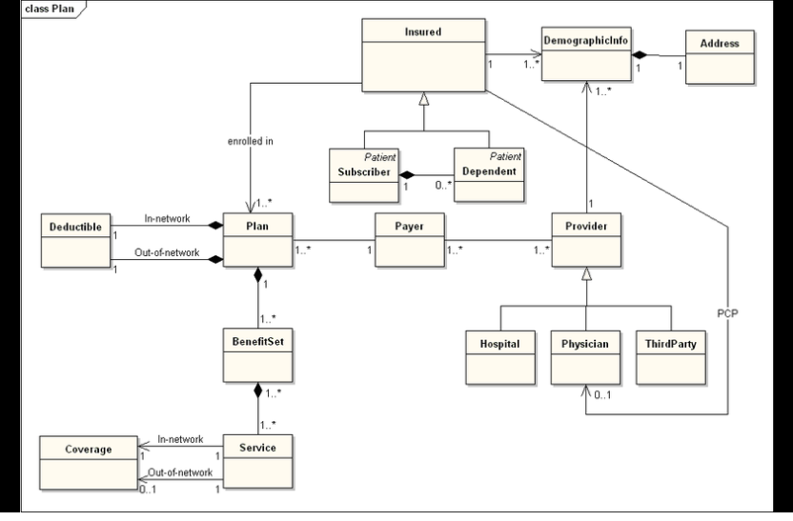
E.g Domain Model of health insurance plan

Event-Response Tables
In order to develop Event Response table fisrt it is required to identify all possible events. Following is an example of events list and event-response table of higway intersection system.

The highway intersection system described earlier has to deal with various events, including these:
- A sensor detects a car approaching in one of the through lanes.
- A sensor detects a car approaching in a left-turn lane.
- A pedestrian presses a button to request to cross a street.
- One of many timers counts down to zero.

Table 4 presents a fragment of what an event-response table might look like for such a system. Each expected system behavior consists of a combination of event, system state, and response.
Note: You may add more information to event-response table in order to perform detail requirement analysis which includes:
- The event frequency (how many times the event takes place in a given time period, or a limit to how many times it can occur).
- Data elements that are needed to process the event.
- The state of the system after the event responses are executed.

Table 4 Partial Event-Response Table for a Highway Intersection
Event | System State | Response
Road sensor detects  vehicle entering left-turn  lane. | Left-turn signal is red. Cross-traffic signal is green. | Start green-to-amber  countdown timer for cross-traffic  signal.
Green-to-amber  countdown timer reaches  zero. | Cross-traffic signal is green. | 1. Turn cross-traffic signal amber.  2. Start amber-to-red countdown timer.
Amber-to-red  countdown timer reaches  zero. | Cross-traffic signal is amber. | 1. Turn cross-traffic signal red.  2. Wait 1 second.  3. Turn left-turn signal green.  4. Start left-turn-signal countdown timer.
Pedestrian presses a  specific walk-request  button. | Pedestrian sign is solid Don’t Walk.  Walk-request countdown timer is not activated. | Start walk-request countdown timer.
Pedestrian presses  walk-request button. | Pedestrian sign is solid Don’t Walk.  Walk-request countdown timer is activated. | Do nothing.
Walk-request  countdown timer reaches  zero plus the amber  display time. | Traffic signal in walk  direction is green. | Change all green traffic signals to amber.
Walk-request  countdown timer reaches  zero. | Traffic signal in walk  direction is amber. | 1. Change all amber traffic signals to red.  2. Wait 1 second.  3. Set pedestrian sign to Walk.  4. Start don’t-walk countdown timer.

Story Boarding
Following is an example of story boarding which is use to identify and analyze graphically intensive applications.

